**Full Stack Development with MERN**

# 1. Introduction

**Project Title:** Flight Booking using MERN **Team Members:**

* Krishnan G
* Jeredson Daniel Raj S
* Vignesh C
* Mohammed Musthaba Majith A

# 2. Project Overview

**Purpose:** This project aims to create a responsive and user-friendly online flight booking system. It allows customers to search for flights, book tickets, and monitor booking status. Administrators can manage flight schedules and handle booking records.

**Features:**

* User registration and login with JWT authentication.
* **Flight management** (create, update, delete flight schedules).
* **User dashboard** for booking status and history tracking. • **Admin dashboard** for flight and booking management.

# 3. Architecture

* **Frontend:** Built using React, the frontend provides a dynamic user interface for the flight booking system. It includes components for user authentication, flight search, and booking management, using React Router for seamless navigation.

* **Backend:** The backend is built with Node.js and Express.js. It handles requests, manages authentication, processes bookings, and connects with MongoDB for data storage. Controllers manage flight data and user bookings.

* **Database:** MongoDB stores information about users, flights, and bookings. It is structured with collections for each major feature (e.g., users, flights, bookings) to enable quick retrieval and updates.

# 4. Setup Instructions

**Prerequisites:**

* Node.js v14+
* MongoDB v4+
* (Optional) npm or yarn for package management **Installation:**

1. Clone the repository: git clone <repository-url>
2. Navigate to both the backend and frontend directories and install dependencies:

For Backend: cd backend

npm install

For Frontend: cd ../frontend npm install

1. Set up environment variables by creating a .env file in the backend directory with database connection strings, JWT secret, etc.

# 5. Folder Structure

**Client:**

The frontend directory contains:

* src/components - Contains reusable React components.
* src/pages - Different pages (e.g., FlightList, Login, Register).
* src/utils - Utility functions and API calls.
* src/styles - CSS files for styling.

**Server:**

The backend directory is organized as follows:

* config - Database connection configuration.
* controllers - Functions to handle business logic.
* routers - Defines routes for various API endpoints.
* middlewares - Middleware for authentication and error handling.
* schemas - MongoDB schemas and models.

# 6. Running the Application

**Frontend:**

Start the frontend server: npm start **Backend:**

Start the backend server: npm start

# 7. API Documentation

The backend exposes several endpoints, including:

* **POST** /api/components/login.jsx- User login with JWT authentication.
* **POST** /api/components/register.jsx - User registration.
* **GET** /pages/FlightBookings.jsx- Fetch available flights based on search criteria.

**Example Response:**

{

"status": "success",

"data": {

"flights": [

{

"id": "flight-id",

"airline": "Airline Name",

"departure": "Departure Location",

"destination": "Destination Location",

"departure-Time": "YYYY-MM-DDTHH:MM:SS",

"arrival-Time": "YYYY-MM-DDTHH:MM:SS",

"price": "Flight Price"

}

]

}

}}

# 8. Authentication

Authentication is handled using JWT tokens. After login, users receive a token stored in local storage. Protected routes require a valid token for access, which is verified using middleware.

# 9. User Interface

The interface includes:

* Login and registration form for user authentication.
* Flight search page displaying available flights based on user preferences.
* Dashboard page where users can view their booking history and monitor current booking status.

# 10. Testing

Testing is performed using tools like Jest and Postman for API testing. Unit tests cover component functionality and API response validation.

**11. Screenshots**

# Landing page

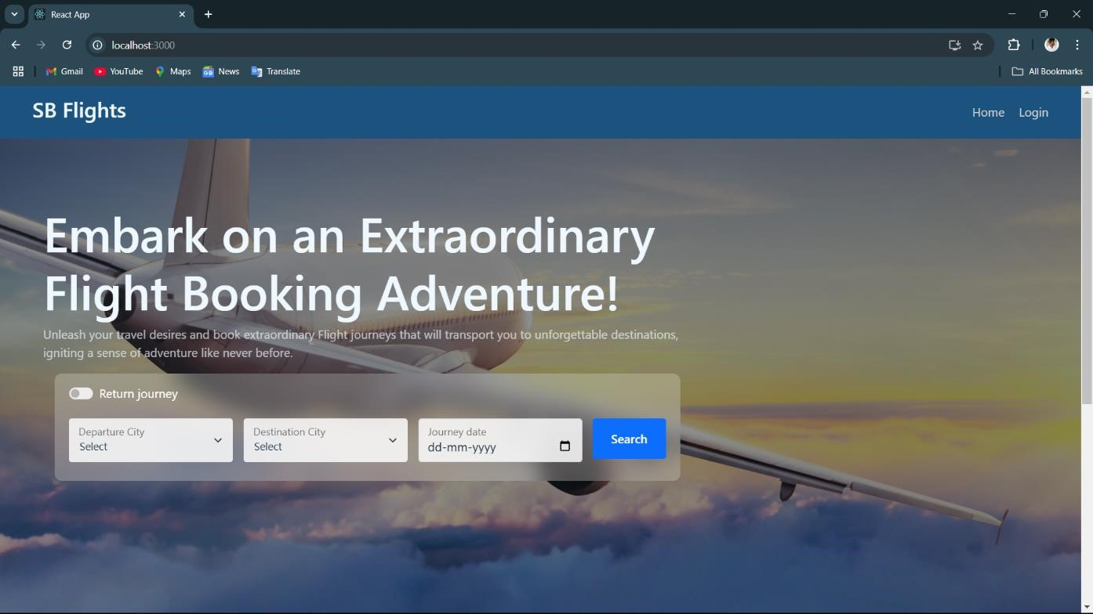

# Login Form and Authentication

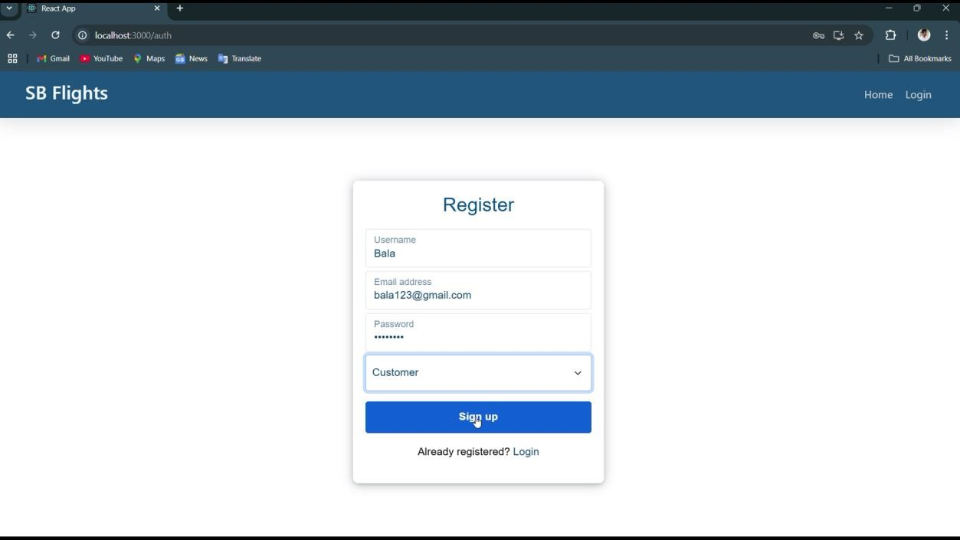

# User Bookings

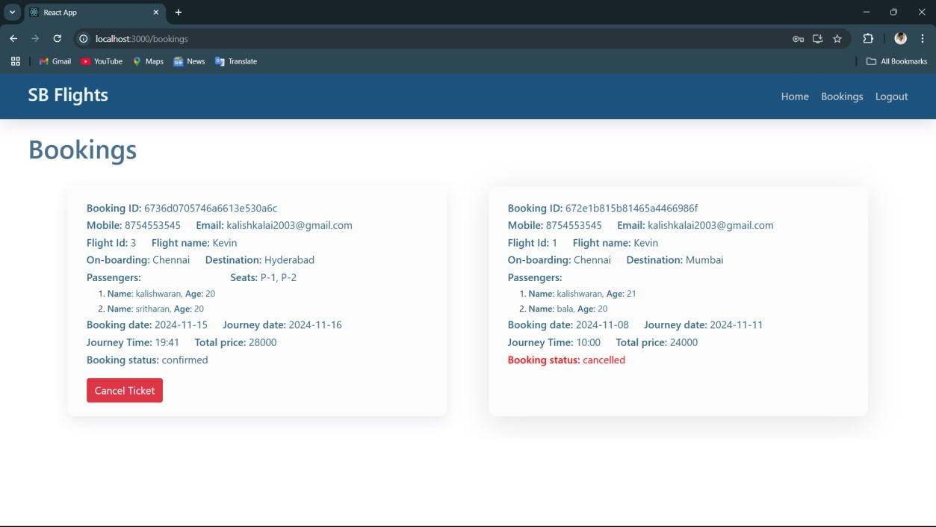

# Admin Dashboard

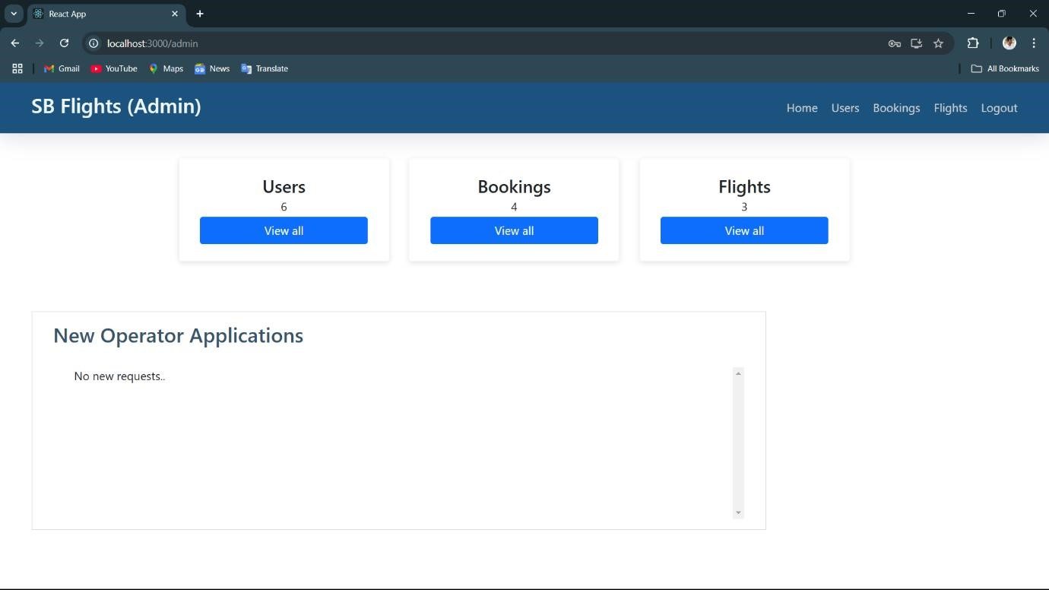

# Flight Ticket Booking

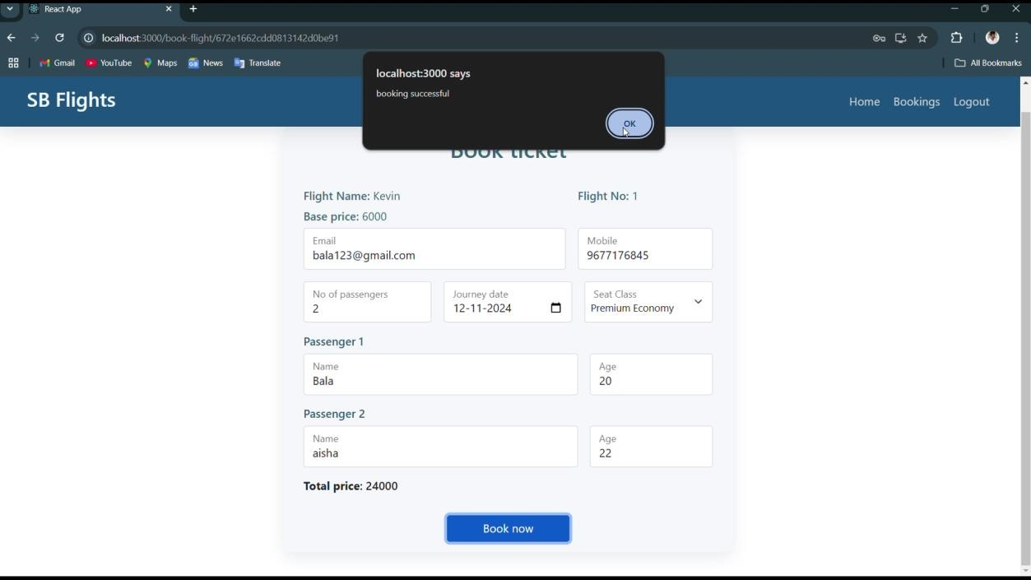

# All Flight Bookings

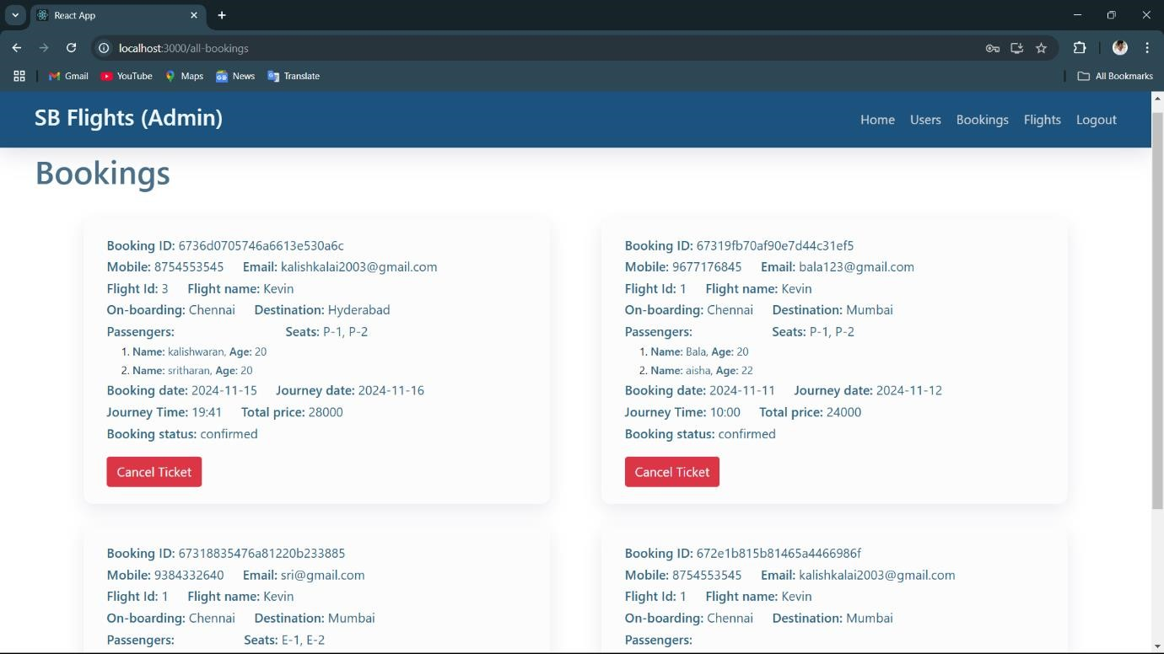

# All Users

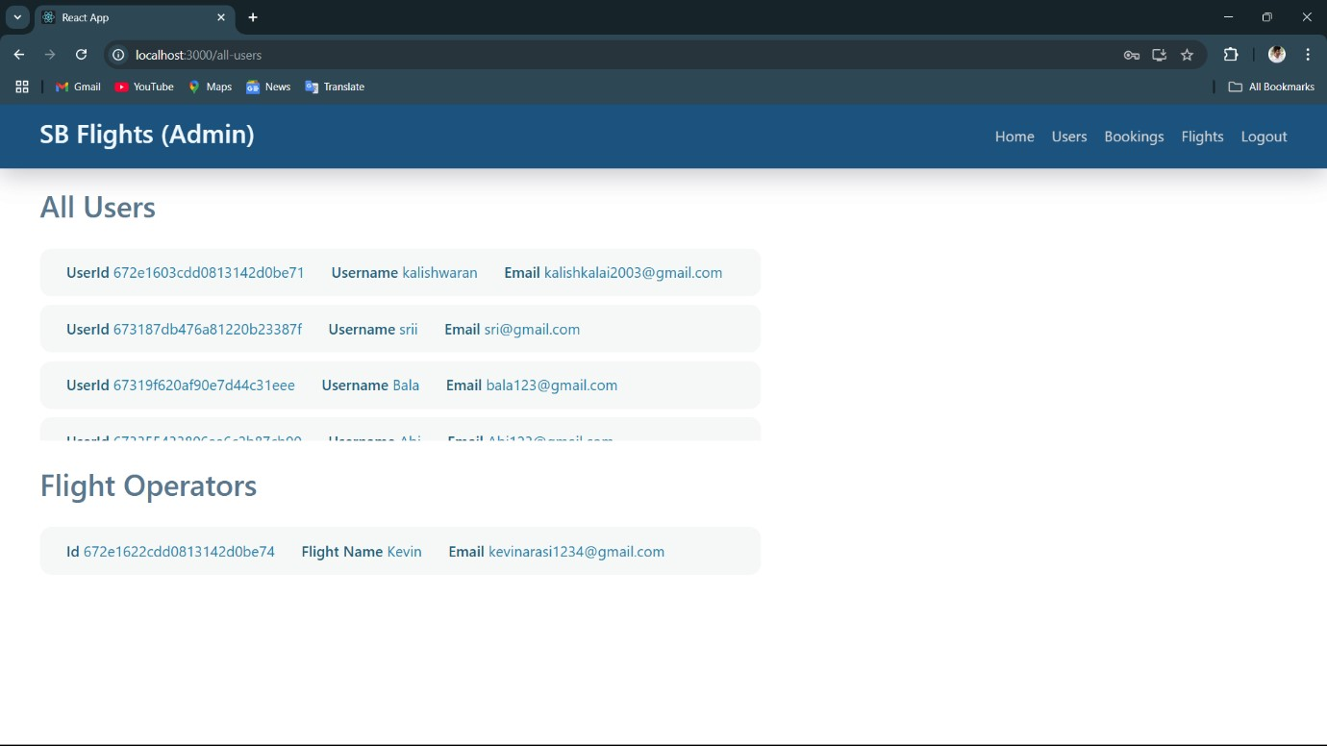

# Flight operator

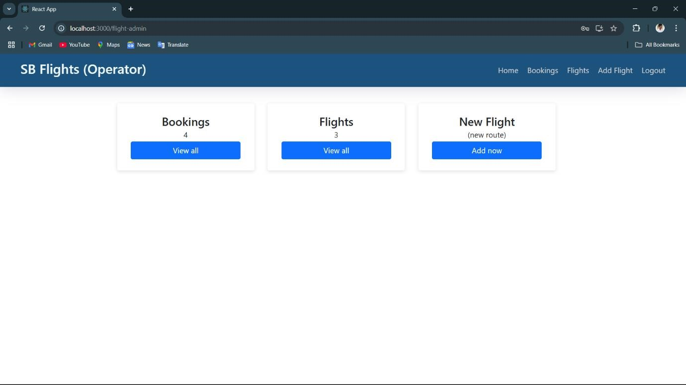

# New Flights

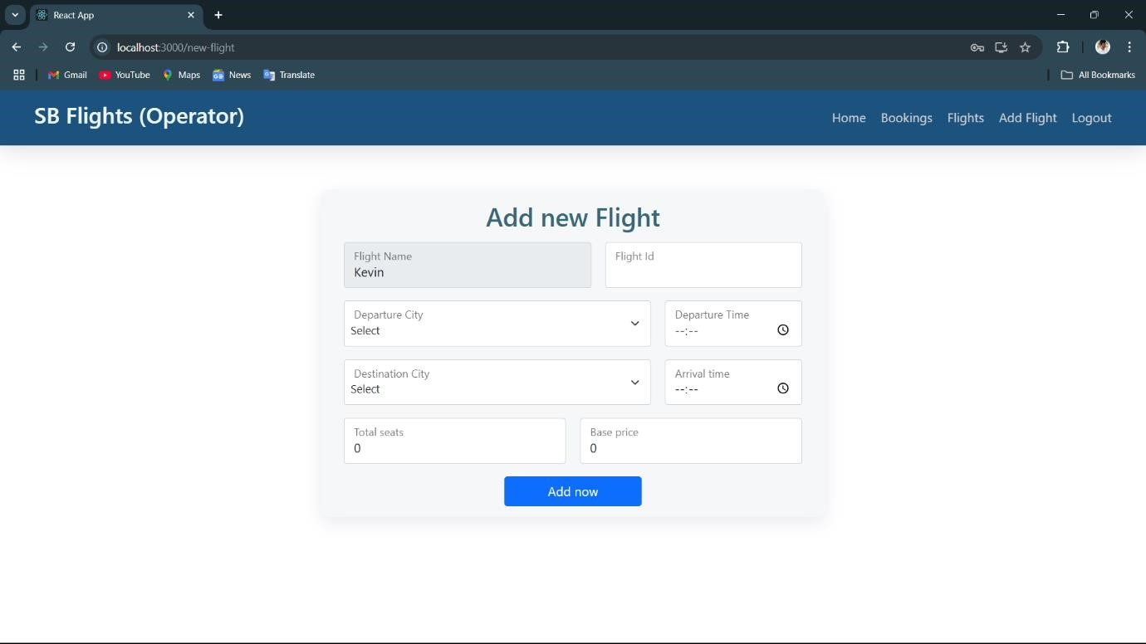

# Code

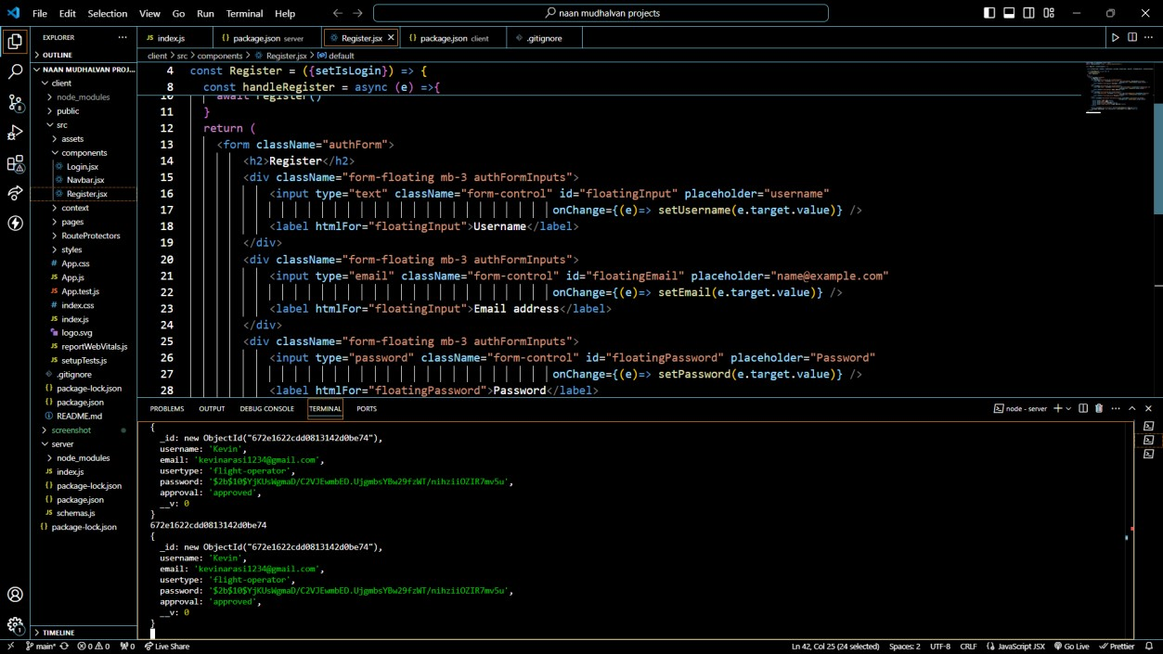

.

# 12. Known Issues

* Session expiration may log users out unexpectedly.
* Occasional delays in fetching flight data during high traffic.

# 13. Future Enhancements

* Add support for filtering flights based on additional criteria like layovers and baggage options.
* Implement seat selection functionality during booking.
* Enhance user experience with real-time flight status updates.